Maven specs after installation:

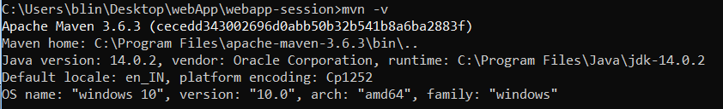

Creating a sample project using maven:

*mvn archetype: generate -****DgroupId=com.accolite.au*** *-****DartifactId=maven-session*** *-Dpackage=com.accolite.au -Dversion=1.0 -DarchetypeArtifactId=****maven-archetype-quickstart*** *-DinteractiveMode=false*

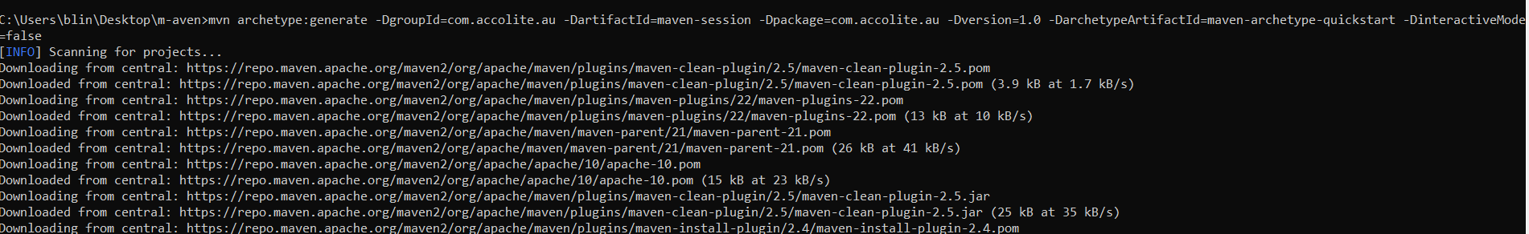

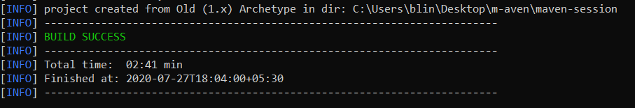

*Directory Structure:*

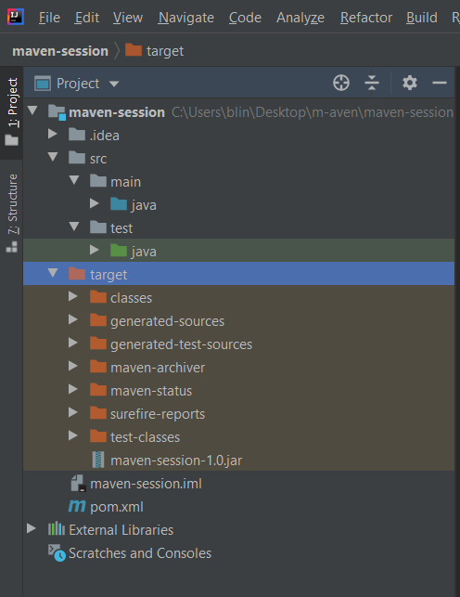

*The pom.xml file:*

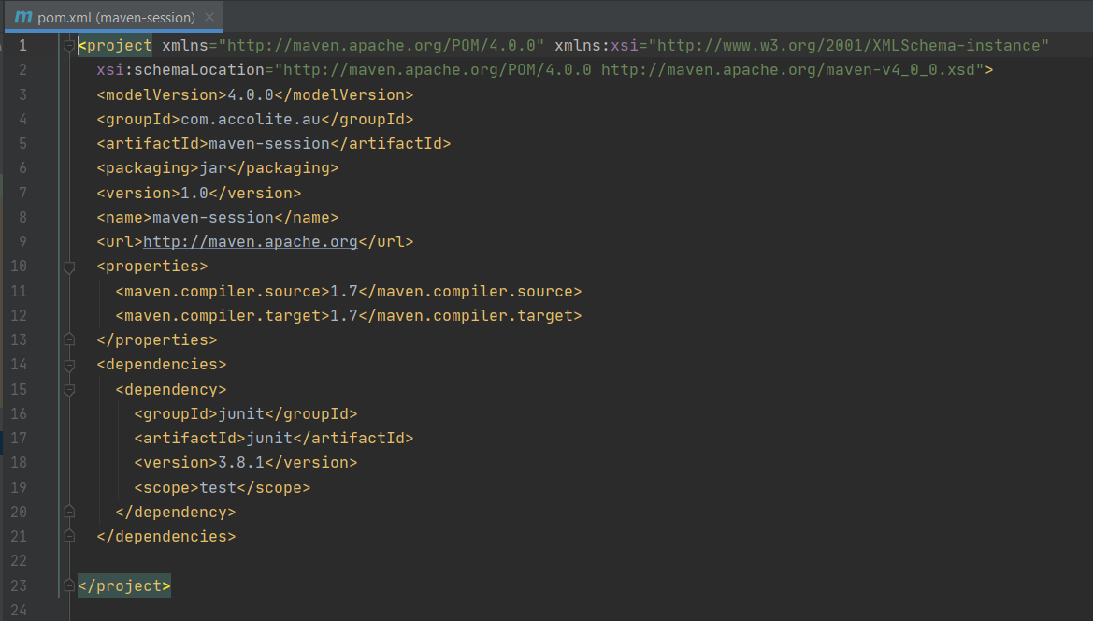

changing the directory to maven-session, run the following command:

*mvn install*

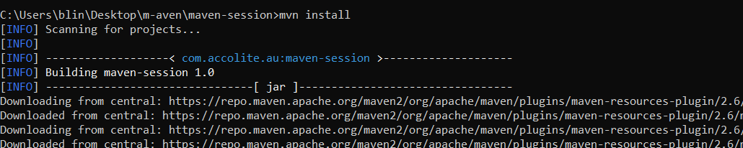

To run the project*:*

*mvn exec:java -Dexec.mainClass=com.accolite.au.App*

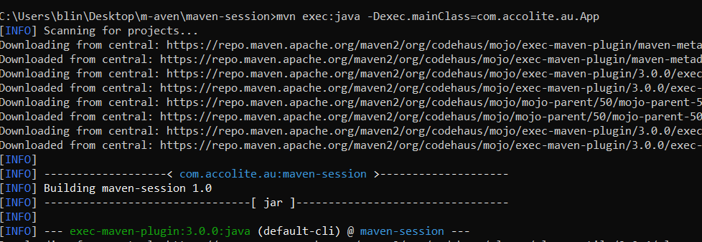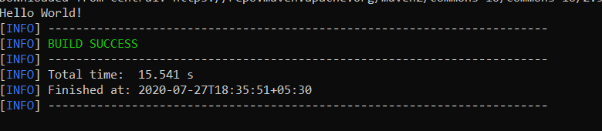

*2.*Creating the WebApp requires mentioning the DarchetypeArtifactId accordingly:

*mvn archetype:generate -DgroupId=com.Khushbu.au -DartifactId=webapp-session - -DarchetypeGroupId=org.apache.maven.archetypes -DarchetypeArtifactId=maven-archetype-webapp -DarchetypeVersion=1.4*

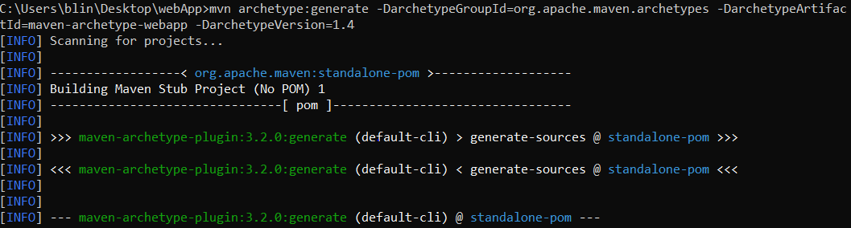

*Inputs provided:*

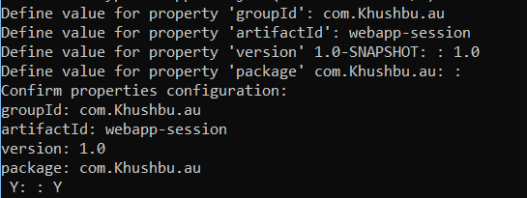

*Changing to the webapp-session directory and running:*

*mvn install*

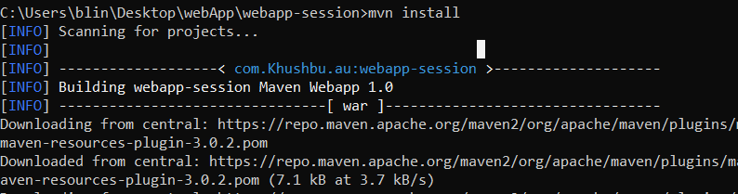

*Directory Structure:*

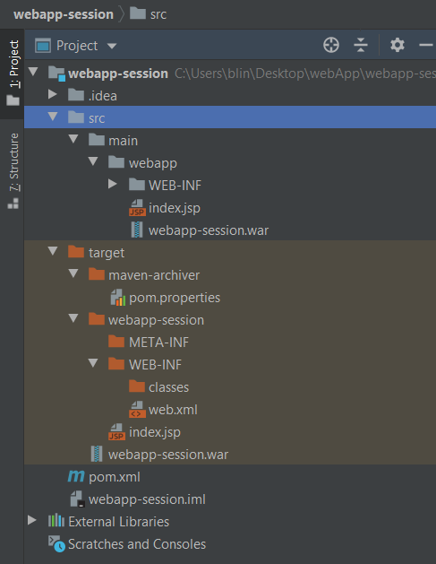

*The pom.xml file:*

